Apples to Apples

Behaviors and Actions
Below are the classes and their functions with desctiprions.
- Game
  - makeApples() = Creates both the red and green apples (cards)
  - dealCard(cardType) = Deals a card. Red or green defines the card type
  - dealHands() = Deals all players their red apples (up to defined hand size)
  - emptyDeckCheck() = Checks for an empty deck and refills it if so
  - newJudge() = Assigns current Judge for the round
  - gameOver() = Checks players’ for scores matching the predefined win condition
  - displayScores() = Shows all players and their scores
  - displayTable() = Shows all cards on the table
  - main() = The game’s runner class essentially

- Player
  - winRound() = increments score
  - getRoundsWon() = returns score
  - setPlayerNum(pNum) = sets player identifier to pNum
  - getPlayerNum() = returns player identifier
  - setIsJudge(state) = sets whether or not the Player is the current Judge (state can be true or false)
  - getIsJudge() = return whether or not the Player is the current Judge
  - drawNewCard(card) = adds a card to the player’s hand
  - chooseCard() =
  - chooseFromTable() = Allows a Judge player to choose from the table
  - displayHand() = Shows the Player’s hand

- Card
  - getText() = returns the card text
  - getOwner() = returns a reference to the owning Player
  - setOwner(player) = sets a reference variable for an owning Player in Card to player, the new owner
  - getNextCard() = returns a reference to another card in a linked list
  - setNextCard() = sets a reference variable to another card in a linked list

- CardBox (meant only for used cards)
  - addCard() = adds card to the cardBox
  - removeCard() = removes a card from the cardBox
  - cardAmt() = returns number of cards within the cardBox
  - shuffle() = shuffles any cards within the cardBox
- GreenCardBox and RedCardBox
  - All functions and variables inherited from CardBox and made static.
Class Diagram:

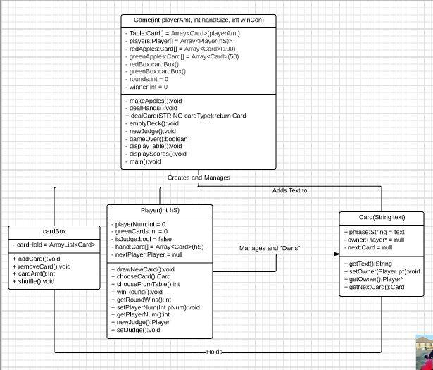

Object Diagram:

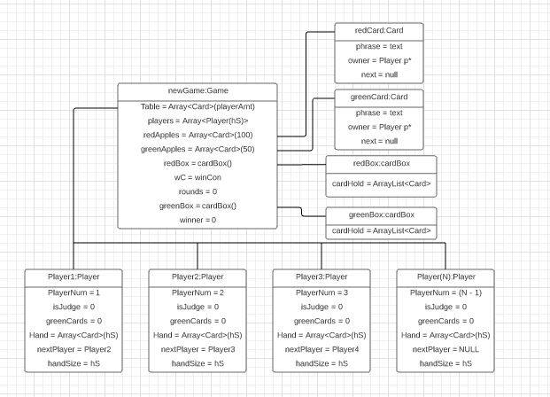
Program Scenario

The program always begins with questions asking how many players there are, the number of cards players should have, and the score to win for that game. Once those questions are answered, a Game is created with those factors with a number of players that is previously defined. Before the actual game begins, red and green “apples” (cards) are made and red apples are dealt to every player to make up their beginning hands up to the hand size previously determined. The first player is assigned to be the judge for the round, becoming unable to play a red apple for that round. Every round, a green apple is added to the “Table” represented by an array and openly displayed. All players except the Judge will remove a red apple from their hand, adding it to Table. Then, the Judge chooses a red apple from the Table and the owner of that card gains a point. After that, every player who placed a card onto the Table draws a new red apple to maintain their hand size, then the next player from the current Judge player becomes the Judge for the next round and the first player is allowed to use their hand again as they are no longer the Judge. This will continue until one player has earned the winning score previously determined.

Use Case Diagram:

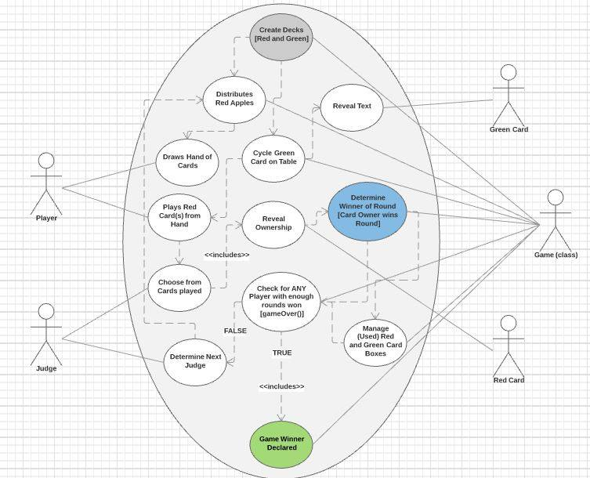
Sequence Diagram:

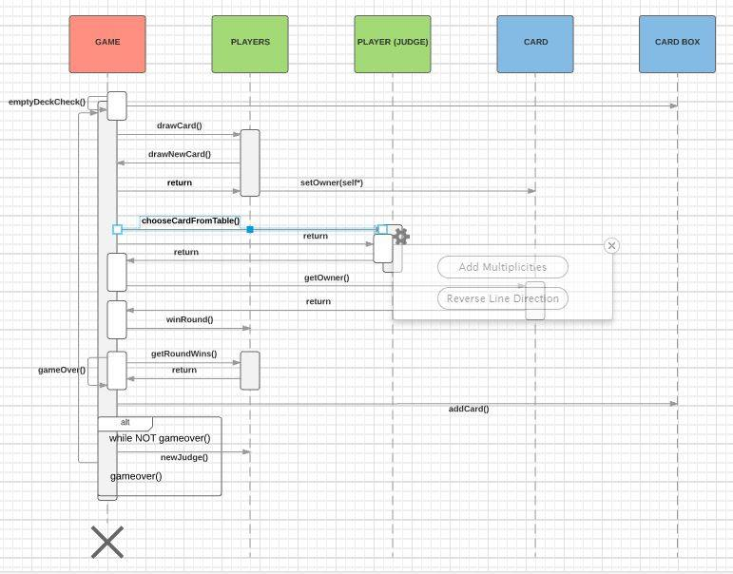

Collaboration

Gerald: Originally I created the basis of the code without concerning detailed logic. Dennis was more involved in finding the correct syntax for the Swift language and implementing any logic that I had missed after I realized a few of such logic holes. During the last couple of weeks to the semester, we worked closely together to implement the remaining portions of logic for the code. The UI was implemented minimally by myself and perfected by Dennis.

Decisions Postponed

- We decided to focus on the UI last, merely because aesthetic is always less important than logic when creating a game. Also, for most of this project’s creation, IO had eluded us both for the Swift language. Meanwhile, many syntax and logical errors needed to be changed before continuing.

- Gerald: I personally decided that the second to last thing would be to have the objects come together within other structures, fixing whatever logic was needed for either communication or movement.

- Dennis: As we began to finish the project I added protocols and some inheritance to make the program easier to work with and understand. This was mainly geared to creating two different card boxes that could be called from inside the Game class without having to be instantiated as separate objects. They both inherent from the cardBox class, however I ended up overriding all of the functions to make them work properly. Originally everything was compiled in one file, so I broke it down forming one per class with the exception of the CardBox file. I also added conditional statements midway through to allow for the use of different libraries since we were jumping between Linux and macOS; this was an issue particularly for the development of the shuffle method since it uses a random number generator.

PseudoCode (Outline / Shorthand)

CLASS Game( INTEGER playerAmt, INTEGER handSize, INTEGER winCon ){
ASSIGN Array<Card>(playerAmt) to Table[]
ASSIGN Array<Player( ASSIGN handSize to INTEGER hS )>(playerAmt) to players[playerAmt]
ASSIGN Array<Card>() to redApples[]
ASSIGN Array<Card>() to greenApples[]
ASSIGN cardBox to redBox
ASSIGN cardBox to greenBox
ASSIGN winCon to INTEGER wC
ASSIGN 0 to INTEGER winner
ASSIGN 0 to INTEGER rounds

FUNCTION makeApples() //Creates red and green card (apple) decks
FUNCTION dealHands() // Deals out every player’s hand. Only used once
FUNCTION dealCard( STRING cardType ) //Deals out a red or green apple depending on the card type
FUNCTION emptyDeck() // Checks if each deck is empty. Will refill one if so
FUNCTION newJudge() // Assigns new round Judge
FUNCTION gameOver() // Checks for game over condition (if player score equals winCon)
FUNCTION displayTable() // Displays what is in Table[]
FUNCTION displayScores() // Displays scores of players
FUNCTION main() // Main code for the game
ENDCLASS

CLASS Player( INTEGER hS )
ASSIGN Array<Card>(hS) to Hand[]
ASSIGN 0 to roundsWon
ASSIGN FALSE to isJudge
ASSIGN 0 to playerNum
ASSIGN NULL to Player nextPlayer
ASSIGN hS to handSize

FUNCTION drawNewCard() // Player adds card to hand[]
FUNCTION chooseCard() // Player chooses a card from their hand to play
FUNCTION chooseFromTable( Card Table[] ) // Player (Judge) chooses winning card from table, returns the player’s ID.
FUNCTION winRound() // Increments score
FUNCTION getRoundsWon() // Returns score
FUNCTION setPlayerNum( INTEGER pNum ) // Set player identifier
FUNCTION getPlayerNum() // Return player identifier
FUNCTION setIsJudge(bool a) // Sets isJudge state (true or false)
FUNCTION getIsJudge() // Returns isJudge state (true or false)
FUNCTION displayHand() // Displays cards in hand
ENDCLASS

CLASS Card( STRING text )
ASSIGN text to STRING text
ASSIGN NULL to Player owner
ASSIGN NULL to Card next

FUNCTION getText() //Returns the text from the card
FUNCTION setOwner( Player p ) //Sets the owner of the card
FUNCTION getOwner() //Returns the owner of the card
FUNCTION getNextCard() //Sets the next card in a list
FUNCTION setNextCard() //Returns the next card in a list
ENDCLASS

CLASS CardBox
ASSIGN ArrayList<Card> to cardHold

FUNCTION addCard( Card card ) //Adds card to cardHold
FUNCTION removeCard() // Removes and returns card from cardHold
FUNCTION cardAmt() // Returns number of cards in cardHold
FUNCTION shuffle() // Shuffles the cards in cardHold
ENDCLASS

State Chart:

